App name: Clash Royale

- Description:
Enter the Arena! From the creators of Clash of Clans comes a real-time multiplayer game starring the Royales, your favorite Clash characters and much, much more.
Collect and upgrade dozens of cards featuring the Clash of Clans troops, spells and defenses you know and love, as well as the Royales: Princes, Knights, Baby Dragons and more. Knock the enemy King and Princesses from their towers to defeat your opponents and win Trophies, Crowns and glory in the Arena. Form a Clan to share cards and build your very own battle community.
Lead the Clash Royale Family to victory!
PLEASE NOTE! Clash Royale is free to download and play, however, some game items can also be purchased for real money. If you do not want to use this feature, please set up password protection for purchases in the settings of your Google Play Store app. Also, under our Terms of Service and Privacy Policy, you must be at least 13 years of age to play or download Clash Royale.
A network connection is also required.
FEATURES
Duel players from around the world in real-time and take their Trophies
Earn chests to unlock rewards, collect powerful new cards and upgrade existing ones
Destroy opponents towers and win Crowns to earn epic Crown chests
Build and upgrade your card collection with the Clash Royale Family along with dozens of your favorite Clash troops, spells and defenses
Construct your ultimate Battle Deck to defeat your opponents
Progress through multiple Arenas all the way to the top
Form a Clan to share cards and build your very own battle community
Challenge your Clanmates and friends to a private duel
Learn different battle tactics by watching the best duels on TV Royale

- Goal model:

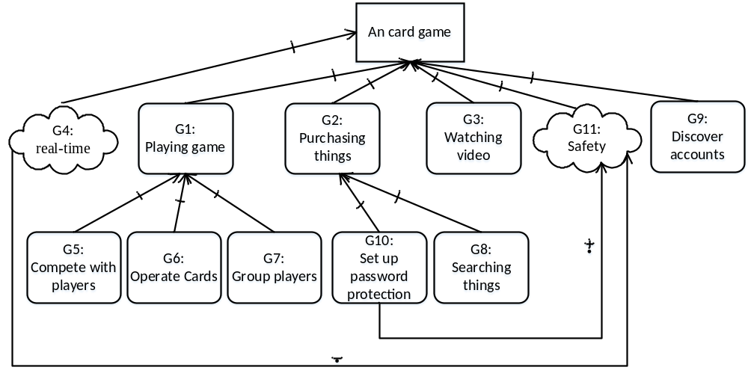

- The description of each goal

ID | Des | Type
G1 | Playing game | Hard goal
G2 | Purchasing game items with real money | Hard goal
G3 | Watching videos on TV Royale | Hard goal
G4 | All the operations are real-time | Soft goal
G5 | Compete and duel with multiplayers from around the world and take their trophies | Hard goal
G6 | Operate on cards, which are items in the game. Players can earn, share, build, collect and upgrade cards | Hard goal
G7 | Group players, build battle community | Hard goal
G8 | Searching things with keywords | Hard goal
G9 | Discover accounts by inputting user name | Hard goal
G10 | Set up password protection for purchases in the settings of your Google Play Store app | Hard goal
G11 | Safety: guarantee the account is safe | Soft goal

